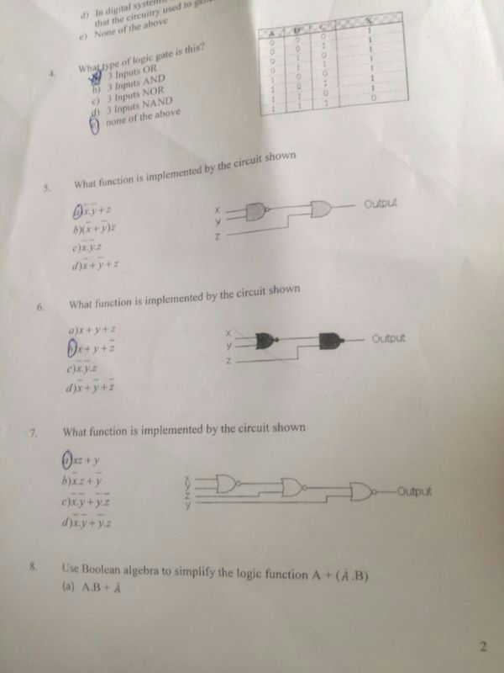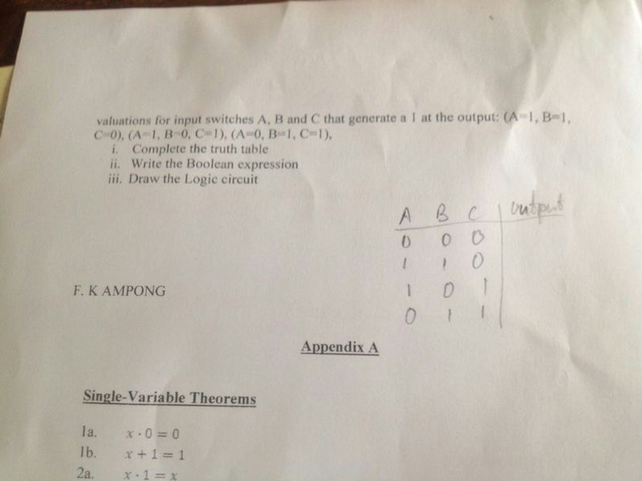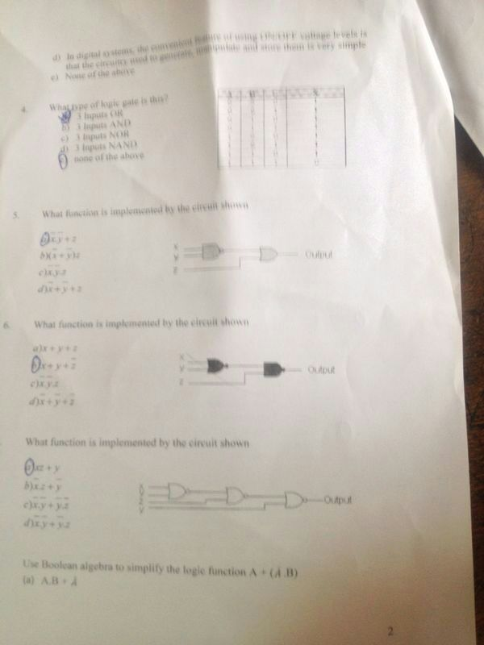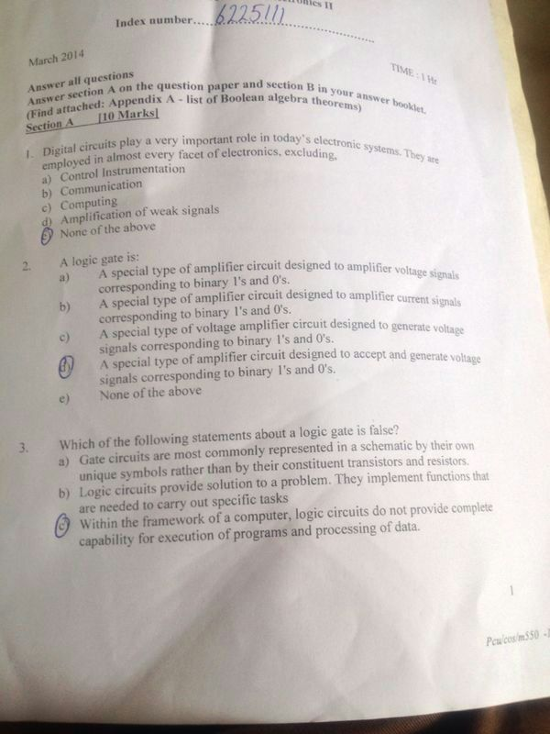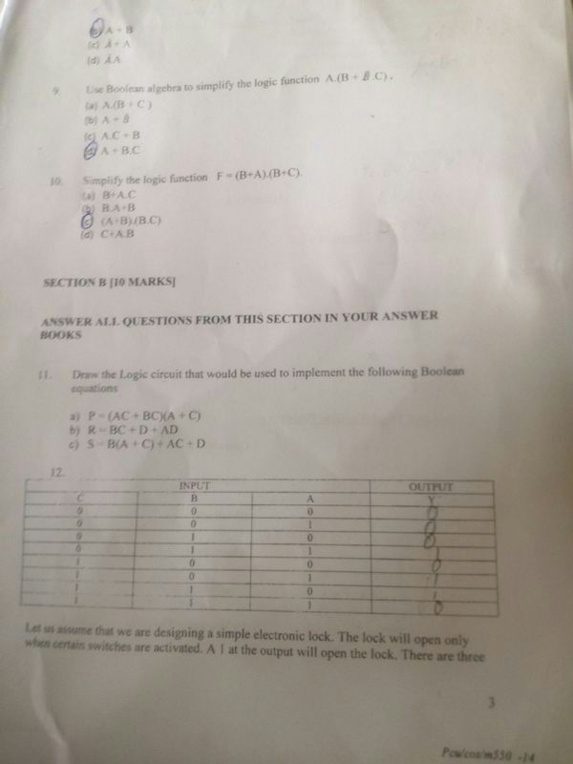

ELECTRONICS II

EXERCISE 2

1. In MOSFET the current control mechanism is based on an _____________ established by the voltage applied to the control terminal.
2. Electric field
3. Induction layer
4. Induced field
5. None of the above
6. In the n-channel depletion-type MOSFET, the threshold voltage is
7. The value of the Gate-to-source voltage at which the channel is completely depleted of electrons.
8. **The value of the Gate-to-source voltage at which a sufficient number of mobile electrons accumulate in the channel region to form a conducting channel.**
9. The value of the saturation voltage.
10. The inversion layer voltage
11. What is an inversion layer?
12. An induced channel
13. A depletion layer
14. A pn junction
15. The gate electrode
16. For the JFET to operate in the pinch-off
17. The drain voltage must be greater than the gate voltage by at least |Vp|.
18. The source voltage must be greater than the drain voltage by –Vp.
19. The gate voltage must be less than the source voltage by –Vp
20. None of the above.
21. The conduction of the channel is proportional to
22. The pn junction voltage between the source and the drain.
23. The excess gate voltage
24. The threshold voltage
25. The inversion layer voltage
26. The maximum value of the gate-to-source voltage in an n-type JFET is
27. –1 V
28. +1 V
29. 0 V
30. 0.7 V

Give the names of the following circuit symbols.

7. 8.

n-channel Enhancement MOSFET n-channel Depletion MOSFET

1. 10.

n-channel JFET p-channel Enhancement MOSFET

1. 12.

p-channel Depletion type MOSFET p-channel JFET

***Example 1***

Design the circuit of fig.1 so that the transistor operates at ID = 0.4mA and VD = +1V. The NMOS transistor has Vt. = 2V, μnCox = 20μA/V2, L = 10 μm, and W = 400 μm. neglect the channel-length modulation effect (i.e. assume λ = 0 ).

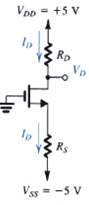

***Example 2***

Design the circuit in fig. 2 to obtain a current ID of 0.4mA. give the value required for R and find the dc voltage VD. Let the NMOS transistor have Vt. = 2 V, μnCox = 20 μA/V2, L = 10 μm, and W = 100 μm. neglect the channel-modulation effect (i.e. assume λ = 0 ).

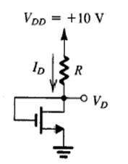

**Digital circuits**

**Short quiz 1**

1. What is meant by the term analog, with regards to an electronic circuit?
2. What is meant by the term digital, with regards to an electronic circuit?
3. A NOT circuit is also called a/an ………………………

4.

|  |  |  |  |
| --- | --- | --- | --- |
| INPUT | | | OUTPUT |
| C | B | A | Y |
| 0 | 0 | 0 | 0 |
| 0 | 0 | 1 | 0 |
| 0 | 1 | 0 | 0 |
| 0 | 1 | 1 | 0 |
| 1 | 0 | 0 | 1 |
| 1 | 0 | 1 | 0 |
| 1 | 1 | 0 | 0 |
| 1 | 1 | 1 | 1 |

Let us assume that we are designing a simple electronic lock. The lock will open only when certain switches are activated. The figure above is a truth table for the electronic lock. Notice that there are two valuations for input switches A, B and C that generate a 1 at the output. A 1 at the output will open the lock.

1. Write the Boolean expression
2. Draw the Logic circuit

5. A certain application requires that two lines be monitored for the occurrence of a HIGH level voltage on either or both lines. Upon detection of a HIGH level, the circuit must provide a LOW voltage to energize an alarm circuit.

1. Design the truth table
2. Write the Boolean expression
3. Draw the Logic circuit

6. The logic circuit shown below is used to turn on a warning buzzer at “X” based on the input conditions at A, B, and C. A simplified equivalent circuit that will perform the same function can be formed by using Boolean algebra. Write the equation of the circuit, simplify the equation and draw the logic circuit of the simplified equation.

**B**

**X**

**B**

**B(A+C)**

**A**

**C**

7. Write the Boolean logic equation and draw the logic circuit that represents the following function:

A Bank burglar alarm (A) is to activate if it is after Banking hours (H) and the front door (F) is opened or if it is after Banking hours (H) and the vault door (V) is opened.

The logic level of the variable H is “1” after Banking hours and “0” during Banking hours. F is “1” if the door sensing switch is open and “0” if the door sensing switch is closed. V is “1” if the vault sensing switch is open and “0” if the vault sensing switch is closed.

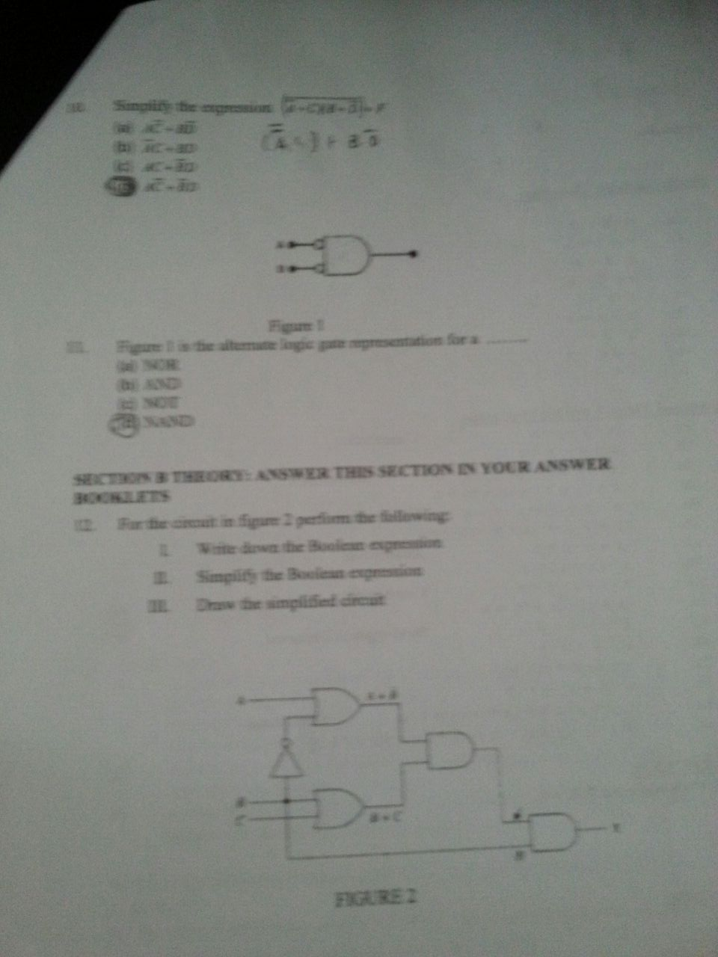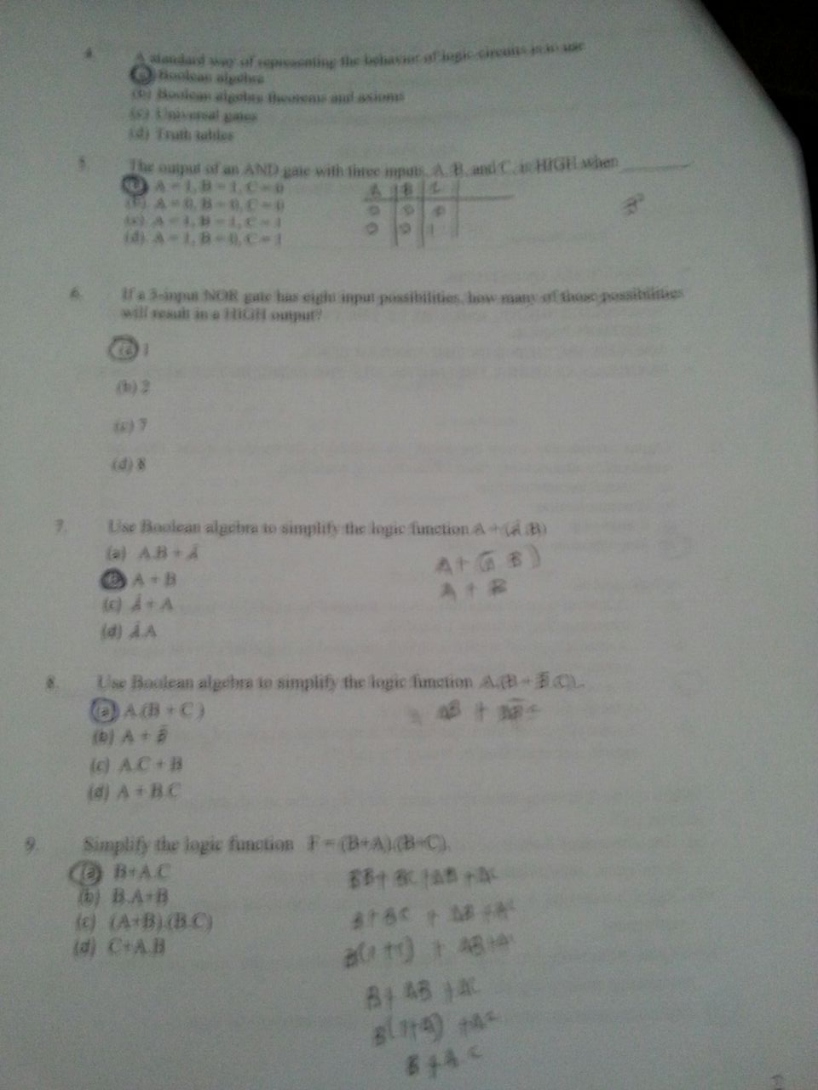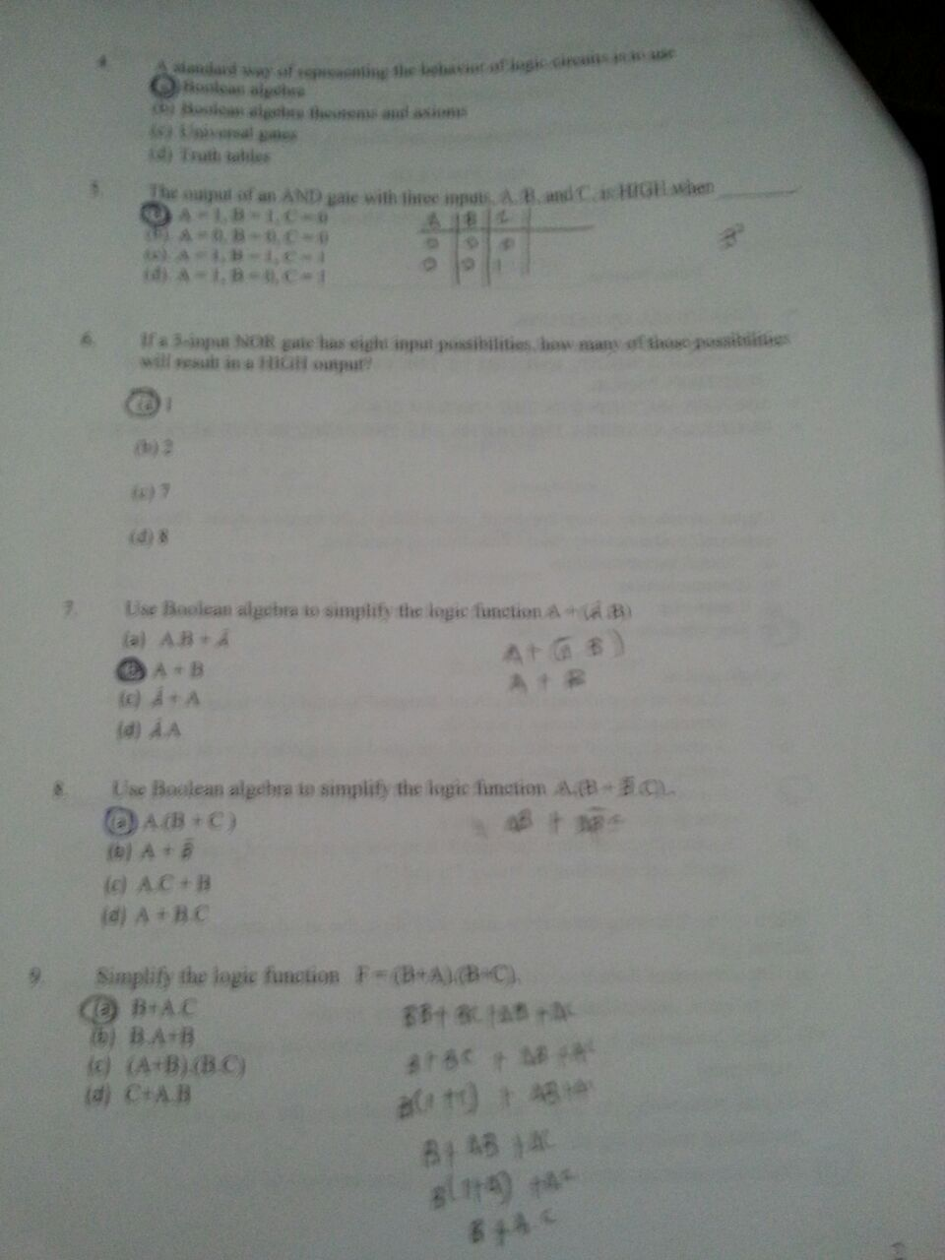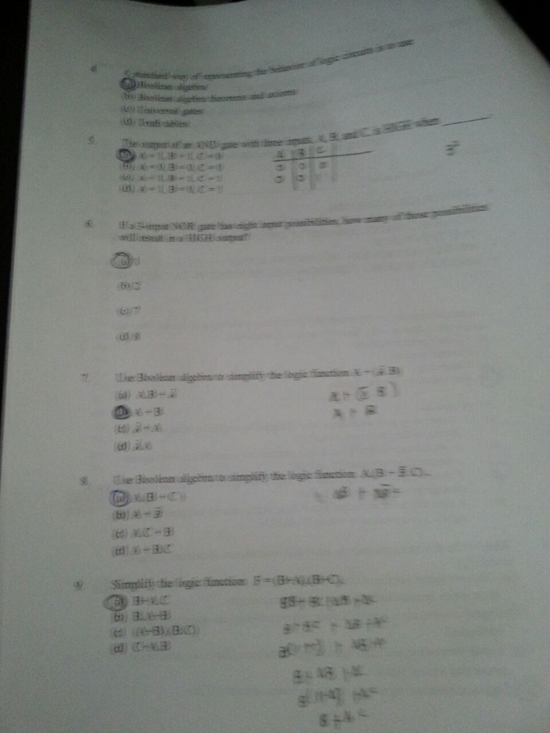

1. Using Boolean algebra, reduce the logic function described to a simpler form and sketch the resulting circuit.
2. If a burglar named Freshman, who has studied Boolean algebra, wants to rob the Bank by tampering with the sensors to prevent the alarm from going off, what would be the easiest way? Explain your answer.

8. Show that the following four circuits are identical in function.









**Single-Variable Theorems**

1a.

1b.

2a.

2b.

3a.

3b.

4a.

4b.

5.

**Two-and Three-Variable Properties**

1a. **Cumulative**

1b.

2a. **Associative**

2b.

3a. **Distributive**

3b.

4a. **Absorption**

4b.

5a. **Combining**

5b.

6a. **DeMorgan’s Theorem**

6b.

7a.

7b.

8a. **Consensus**

8b.

